
SOP Title: | eComm Returns - Tampered Boxes Identification Process
Document Storage Location: | STACS/Management/SOPs – Logistics and Warehousing | Document #: | SEASOP432v100
SOP Originator: | Frank McElligott | Last Edited by: | Erwin Dela Pena
Effective Date: | June 15, 2021 | Last Edited Date: | June 15, 2021
Other:

- Purpose
  - Define process to identify tampered boxes in the eComm Returns process
- Scope
  - Coppell –The eComm returned material process from arrival through 2nd scan, material inspection and transfer to Investigative Security
- Responsibilities
  - 3PL – Performs physical processes, inspects and processes damaged and missing returns and refusals, maintains claimed units in WMS
  - SEA Onsite Uniformed Security - Observes unloading
  - SEA Logistics –Reviews partial missing returns/refusals, coordinats with Claims and Security, and troubleshoots any issues 3PL has
  - SEA Investigative Security –Carries out investigations and removes and holds evidence for investigations
- Instructions:
  - Unloading & Scanning at Dock
    - Geodis unloads boxes in carrier’s truck/trailer returned from customers
    - While unloading the boxes, scan the tracking number of each box into the 3PLs IRR Dock Scan excel document
    - The Security Guard watches the process to make sure nothing is stolen
  - Place boxes on a pallet after dock scanning
    - Refusals and Returns are separated onto separate pallets
      - There are two ways to tell the difference
        - Refusals will have a red tag from FedEX
        - Also Refusals do not have an RMA number
  - Move the pallets to the Returns area
  - Complete a second scan in the 3PL’s system, called Arrival, and an in depth inspection of each returned or refused box
    - Inspect each box for indications of tampering
      - Suspect boxes are to be opened
      - 3PL photographs any boxes with either missing or damaged product. At a minimum take photos of:
        - Label with a clear reading of the tracking number
        - Outside of box showing evidence of tampering
        - Box when initially opened
        - Inside box as they pull out and go through material
      - Under each category below are examples of acceptable and unacceptable returns
        - Acceptable returns look like the below:

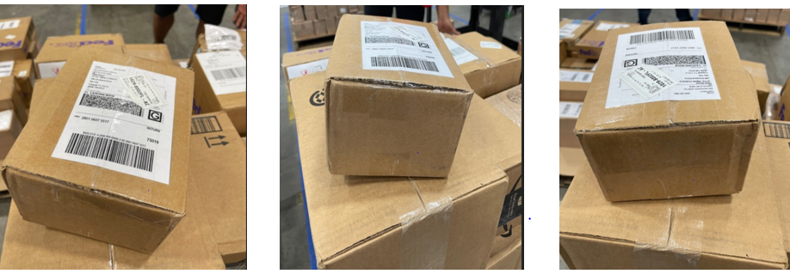

        - Unacceptable returns include:
          - Opened and excessively retaped boxes:
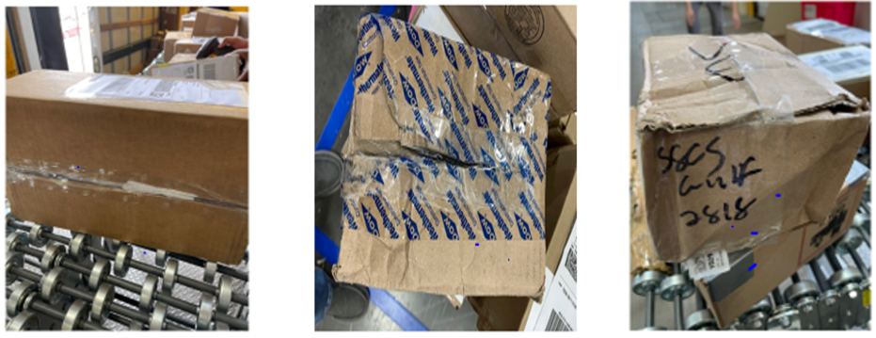
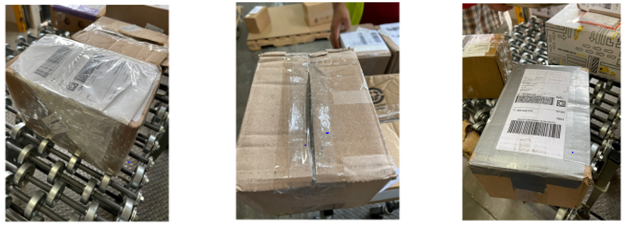
          - Punctured or punched boxes with product removed
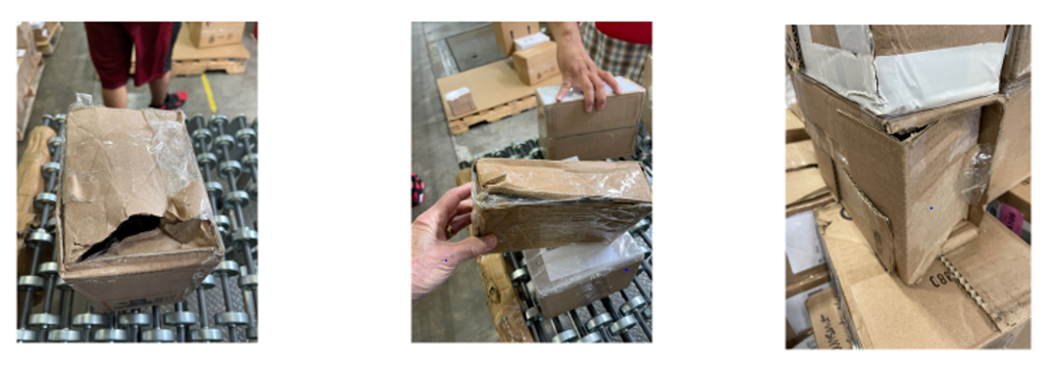
          - Torn or cut open boxes:
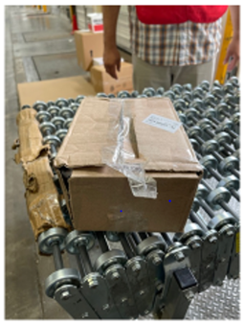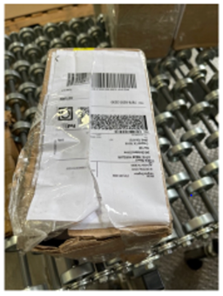
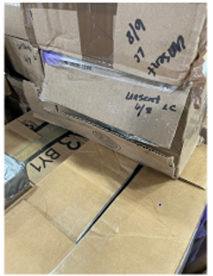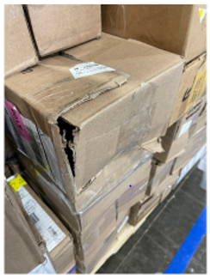

          - End entry & retape:
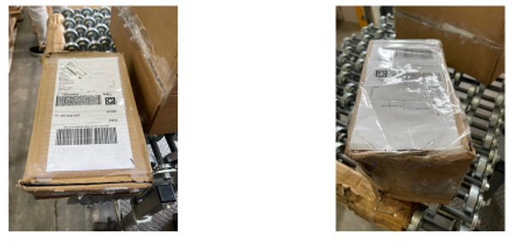
          - Flaps folded indicating opened and then quickly closed and taped
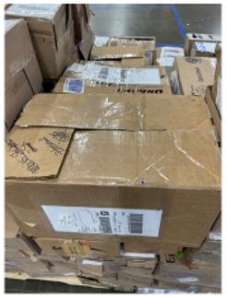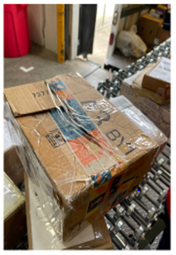

          - Paperwork or packing material sticking out of the box
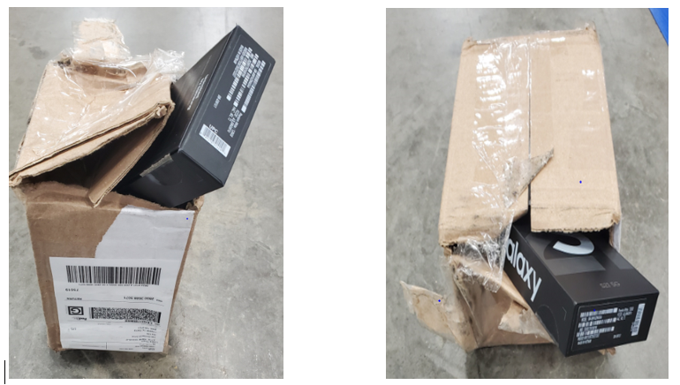
          - Extremely lightweight – indicating the box may be empty
            - Note that it could be extremely light material such as watch bands or label documents.
  - After second scan, Boxes identified as “Tampered” should be placed on two separate pallets
    - First pallet contains parcels that have some material missing, called Partial Refusals
      - SEA Logistics is notified
        - SEA Logistics takes pictures and sends to Claims team
    - The other pallet contains parcels received empty, called Unsent
  - At the end of the business day the 3PL will receive material in their WMS system
    - Damaged material will be handled per the prescribed damaged material process
    - Missing material, including Partial Refusals and Unsent, will be received and closed out
  - Notification to SEA
    - The consolidated Exception Log is sent out daily at the end of the day by 3PL
      - The log lists all exceptions including missing and damaged materials
    - Daily update to Customer Service & Security by SEA eComm Logistics team
      - Segregates Unsent, Empty & Tampered box data
      - Sends an email breaking down how many boxes were logged over the previous five (5) days
    - SEA eComm Logistics sends to SEA Claims Team the following:
      - For partial refusals the following is sent:
        - Filled-out Fedex Report
        - Photographs (attached to email)
      - Email is addressed to:
        - Kalishar Mitchell: kmitchell@sea.samsung.com
        - Gowtham Sivashanmugam : g.sivashanmu@partner.sea.samsung.com
        - Knia Franklin: k.franklin@partner.sea.samsung.com
        - Emanuel Silva: e.silva@partner.sea.samsung.com
    - SEA eComm Logistics sends to Customer Service
      - Logistics makes discovered issues available to eComm Customer Service for further evaluation (determine this process)
  - Two times per week Samsung Cargo Theft Security Investigator will pick up staged pallets of missing material parcels
    - Pallet preparation:
      - Morning of pickup an Investigative form is filled out
      - Placard is to be placed on the pallet including
        - Unique pallet identification sequence
        - Date Range when material added to the pallet

      - Print out corresponding list of items on pallet from Exception Report and staple to Investigative form. Include:
        - SKU
        - Tracking Number
        - RMA
        - Description
        - IMEI
        - Date
        - Pallet ID
      - Both parties sign the form before Investigator removes pallet
    - This pallet will be moved to the evidence storage area for further investigation

- Related Documents:
- Revision History:
Revision# | Date Revised | Document # | Revised By | Change Made (Brief)
1 | 06/15/2021 | SEASOP432v100 | Frank McElligott | Initial Release
2 | 06/15/2021 | SEASOP432v100 | Randell Christopher | Developing SOP
3 | 06/15/2021 | SEASOP432v100 | Erwin Dela Pena | New Owner
4 | 06/17/2021 | SEASOP432v100 | Randell Christopher | Additional Photos

